
Help Sheet
Transferring eBooks to a Portable Device Help Sheet
If you have downloaded an eBook into your computer for reading in “Offline” mode via Adobe Digital Editions, you may transfer it to a supported eReader device.
To learn how to download an eBook using Adobe Digital Editions, please see the Download eBooks on EBSCOhost Help Sheet: http://support.epnet.com/knowledge_base/detail.php?id=5373
Before transferring an eBook, you will need the following:
- A Portable eReader supported for eBooks on EBSCOhost – a list of supported devices is available at: http://www.adobe.com/products/digitaleditions/devices
- Adobe Digital Editions installed on the computer http://www.adobe.com/products/digitaleditions/#fp
- A Valid AdobeID – This may be created for free on following address: https://www.adobe.com/cfusion/membership/index.cfm?nf=1&nl=1&loc=en_us
To transfer an eBook from Adobe Digital Editions to your portable device:
- Open your downloaded eBook in Adobe Digital Editions. If you have not authorized Adobe Digital Editions with your Adobe ID on this computer, you will need to complete that step first. You will be prompted to enter your Adobe ID and Password the first time you try to open a NetLibrary eBook with Digital Editions on your computer.
- Connect your portable device to your computer with a USB cable.
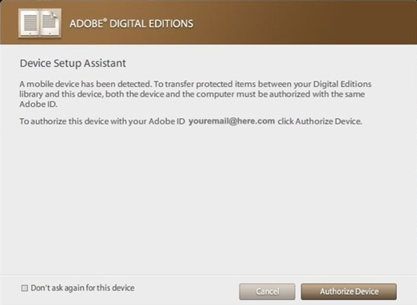
- Turn on the eReader. If the reader offers an option to Recharge or Connect to the computer, choose the “Connect” option.
- Open Adobe Digital Editions – it automatically detects the presence of your device and offers to authorize it with your Adobe ID.
Just as the Adobe Digital Editions software must be authorized with your Adobe ID, the portable device must also be authorized to be able to transfer protected content to and from the device.
- Click Authorize Device in the resulting window (at right).

- Click Finished after your device is authorized.
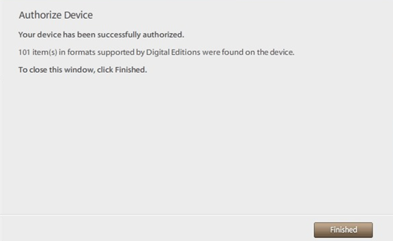

- After authorization, the device appears as a new bookshelf in your library. Transfer items to and from the device bookshelf by clicking on the book title, then dragging and dropping the title into the device bookshelf.
Note: Do not disconnect the device while you are in the process of transferring a title to the device.
