Searching for eBooks Help Sheet
The default search screen for eBooks on EBSCOhost is basic search. The eBook Collection screen displayed below is available by clicking the eBooks link in the top toolbar.
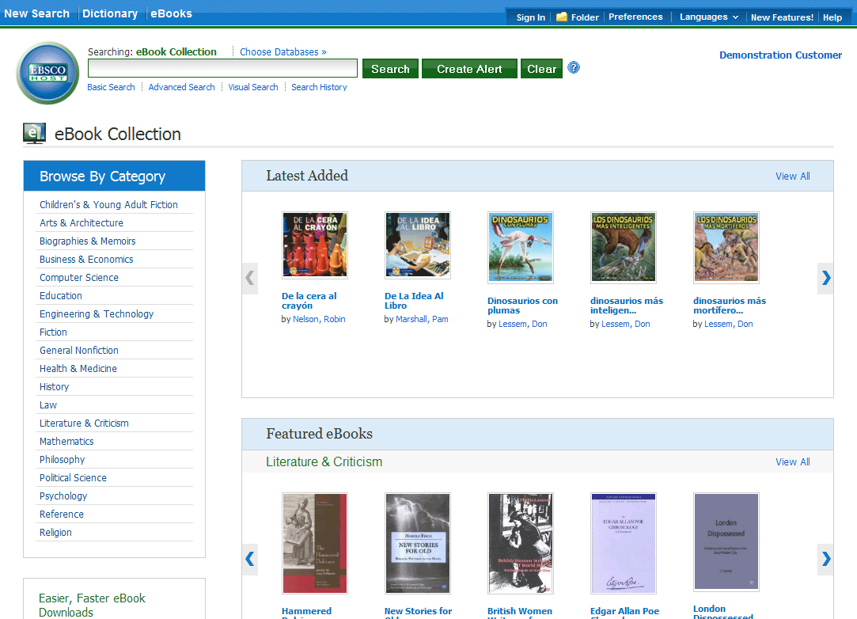
There are several ways to search for eBooks on EBSCOhost:
- Perform a keyword search of the eBooks database using the Find field.
- Browse by Category by selecting a category from the column on the left.
- View the Latest Added eBooks using the left and right arrows or click View All to view a result list of all latest added eBooks.
- View Featured eBooks using the left and right arrows or click View All to view a result list of all Featured eBooks.

To search for eBooks:
- Enter your search terms in the Find field and click the Search button
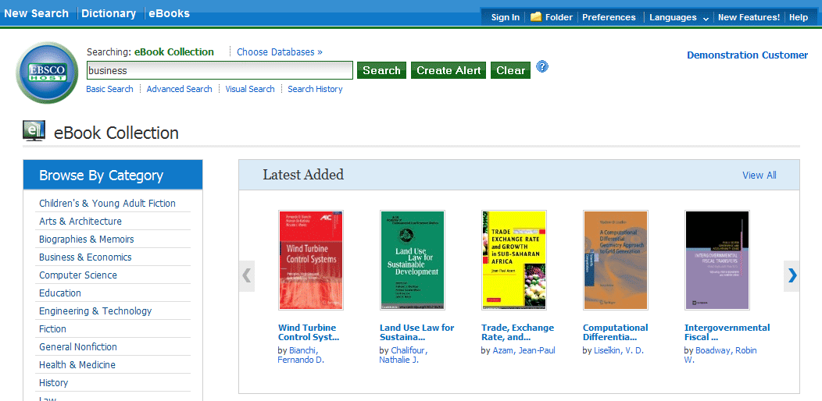
- A Result List of eBooks related to your search terms is displayed.
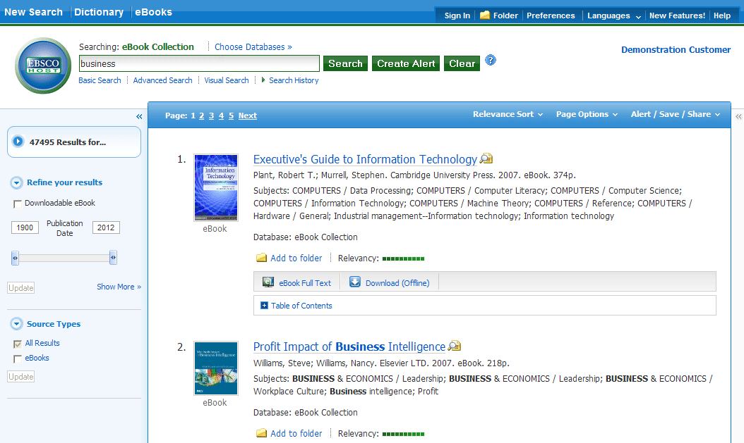
- Click the eBook Full Text link to read the book in the eBook Viewer tool.
- Click the Download (Offline) link to check out the book and read it on your computer using Adobe Digital Editions. (See Downloading an eBook below)
Note: Libraries that have eBook download capabilities enabled will see a Download (Offline) link.
- Click the Table of Contents link to view the chapters of an eBook. You can go directly to a chapter in the eBook Viewer tool by clicking on a hyperlinked chapter.
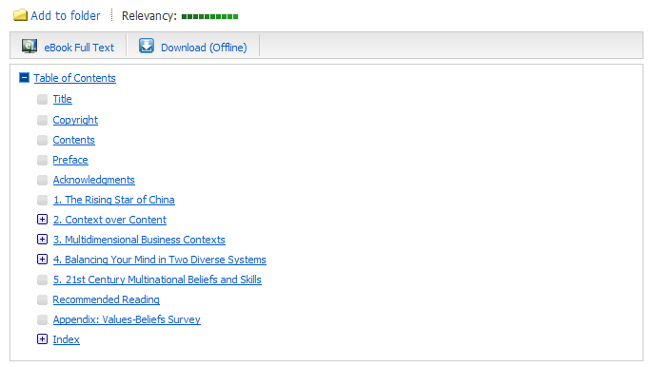
Note: Sections in the Table of Contents with a plus sign (+) can be expanded further by clicking the plus sign.

eBook Viewer
eBooks can be read online in the eBook Viewer by clicking the eBook Full Text link in the Result list or Detailed Record.
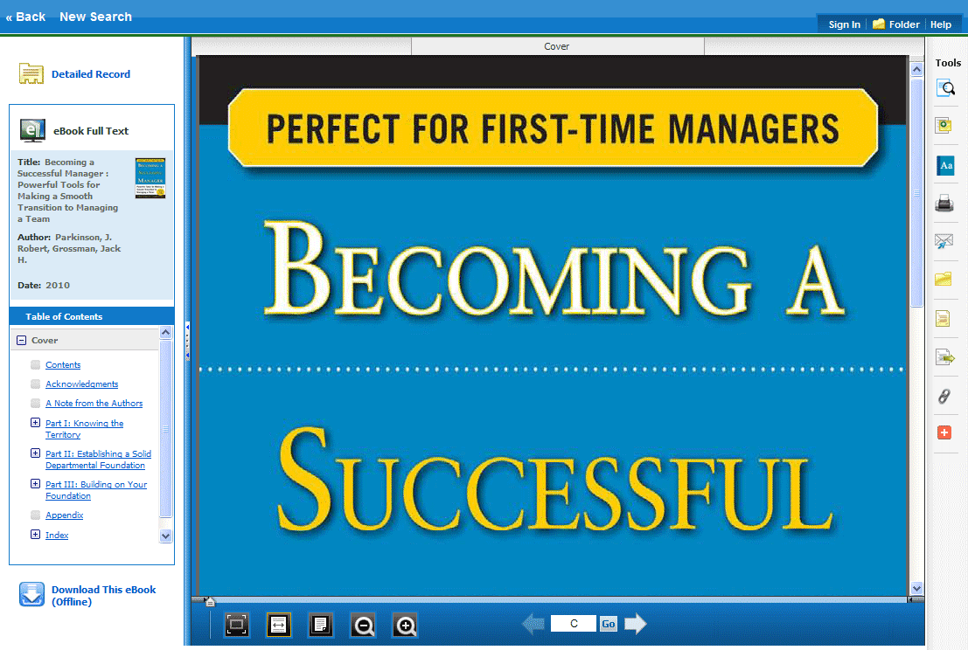
Included in the Tools column on the right, are tools that allow you to search within the text of the eBook and save a note on the eBook in your My EBSCOhost folder.
- - Click the magnifying glass icon to search for terms within the eBook.
- - Click the note icon to create a note about the eBook or a page of the eBook and save it to your personal folder.
- - Click the dictionary icon to search for definitions of words in the eBook you are reading.

Using the eBook Viewer Toolbar
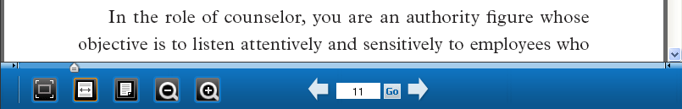
- Fit Page to Viewport: Click the icon to fit the entire page into the viewport.
- Fit Page Width: Click the icon to fit the page by width in the viewing area.
- Fit Page: Click the icon to view the entire page in the viewing area.
- Zoom Out: Click the icon to zoom out on the page.
- Zoom In: Click the icon to zoom in on the page.
- Location Slider: Drag the location slider right or left to go to a specific page of the eBook. The left and right arrows on either side of the slider bar take you to the beginning or end of the eBook. The page number updates in the Page Navigation box as you drag the location slider.
- Page Navigation: Use the page navigation arrows to move up or down one page at a time or enter a page number in the field provided and click Go.

