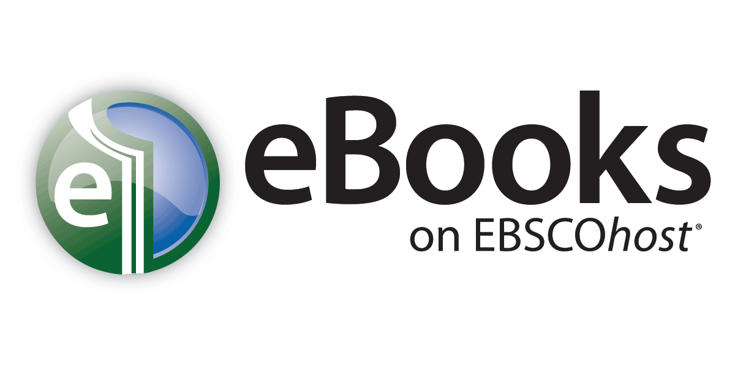
Help Sheet
Downloading eBooks
If your library offers eBook download capabilities, you may choose to download an eBook to your computer and read it offline at a later time. Adobe® Digital Editions 1.7.1 or higher is required for offline viewing. This free software can be downloaded from http://www.adobe.com/products/digitaleditions.

To download an eBook:
- Click the Download (Offline) link for the eBook you would like to download.
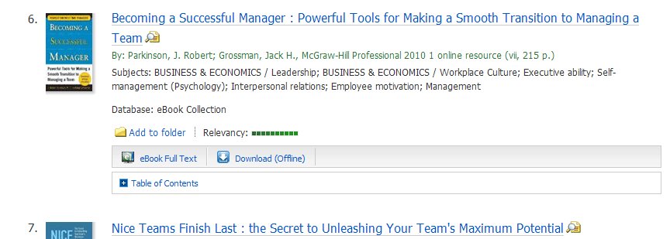

- Select a Checkout period from the drop-down menu and click the Checkout & Download button.
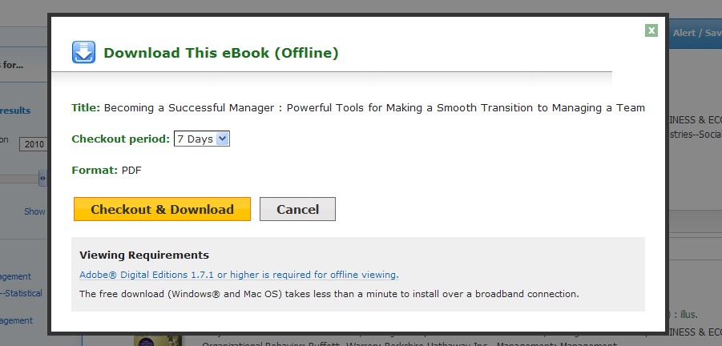
- The eBook is added to the Checkout area of the folder, accessible from the upper-right corner of the EBSCOhost interface. If you are not logged into your My EBSCOhost folder, you are prompted to do so.
- Select Open with or Save File from the resulting dialog box.
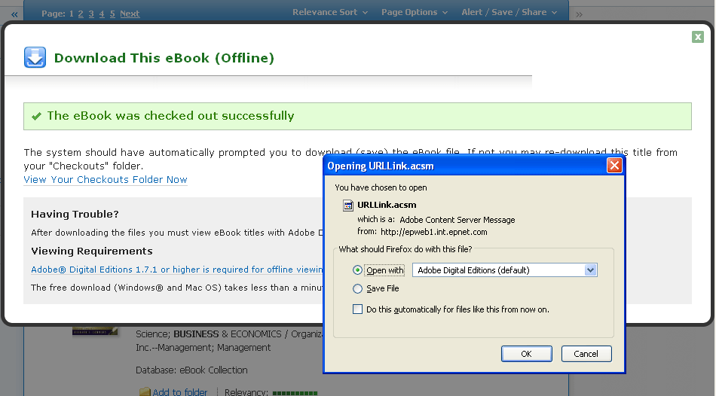
If you select Open with, your eBook is opened with Adobe® Digital Editions. If you select Save file, the eBook is saved to your computer and can be opened with Adobe® Digital Editions at a later time.

- When a downloaded eBook is opened, it is displayed in Adobe® Digital Editions
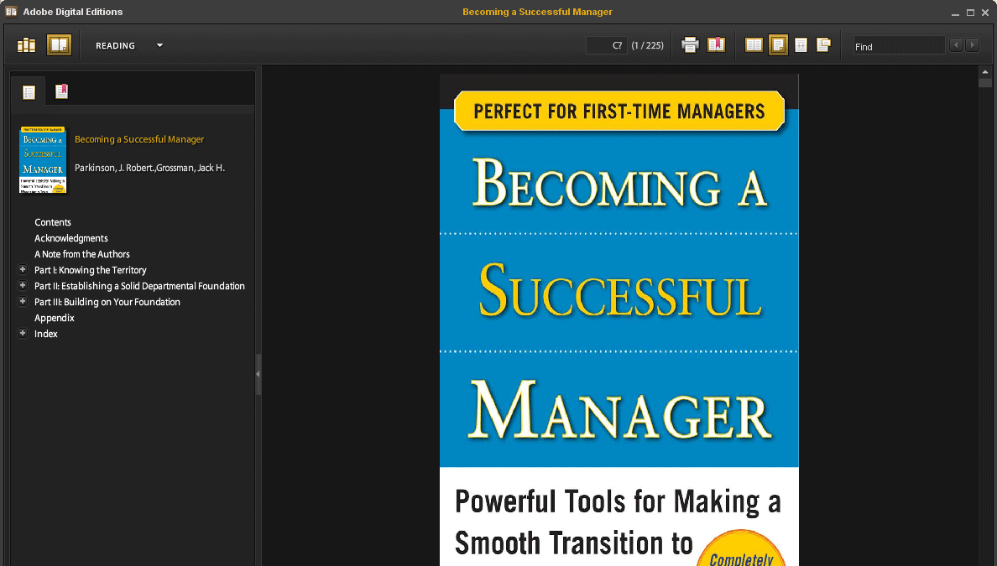

Placing a Hold on an eBook
If the eBook you have chosen to download is in use by another patron, and if your library offers Holds capabilities, you have the opportunity to place a hold on the eBook to download when it becomes available. Enter your e-mail address in the field provided and click the Place Hold button.
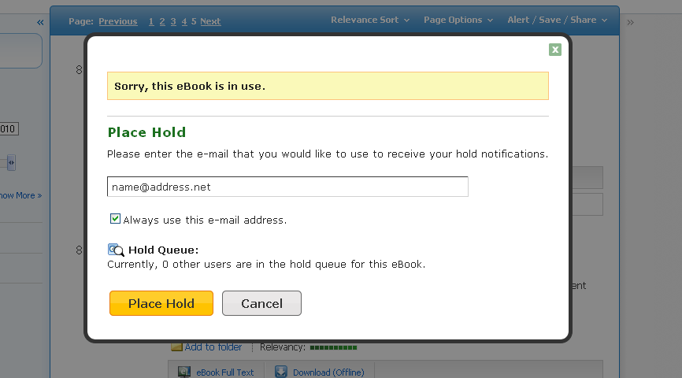
The eBook is placed in the Holds area of your My EBSCOhost Folder. When the eBook is available, you are notified via the e-mail address you provided and the eBook appears in the Checkouts area of your folder.

